**HWZ-EDMW LIKE BOT USER GUIDE**

NUS APPEAL 2017

Gan YunTian

Table of Contents

1. What is this app about? 2

1.1. What does it do? 2

1.2. Why is there a need to do so? 2

1.3. How does the app work? 2

2. Pre-requisite(s) 3

2.1. Does not have a Hardwarezone account. 3

2.2. Already have a Hardwarezone account. 3

3. Login 4

3.1. Start the app. 4

3.2. Allow permission 4

3.3. Actual login. 4

4. After logging in. 5

4.1. Status Page 5

4.2. Statuses 5

5. Logging out 6

5.1. Stopping the app 6

5.2. Waiting for processes to stop. 6

5.3. App fails to stop 7

# 1. What is this app about?

## 1.1. What does it do?

This app automates the task of liking posts on a sub forum called Eat Drink Man Woman @ <http://forums.hardwarezone.com.sg/eat-drink-man-woman-16/> on the website called Hardwarezone.

## 1.2. Why is there a need to do so?

To be honest, the reason this app was developed was to allow me to practice my python skills and at the same time use it for appealing to NUS.

## 1.3. How does the app work?

This app basically runs in a loop. It first uses python libraries to scrap the page source of the forum thereby obtaining the thread links. Then the app will again access the thread links to obtain the page links. Once it has the page links it will pass it into a multiprocessing queue for the threads to get. In total, there are 4 active threads that will be started by the app. These threads each command a headless web driver which will then click the like buttons on the page links. To minimize the app from accessing links already accessed, I have also implemented the usage of dictionaries which keep track of the progress. Besides all that, the main thread handles the main app GUI therefore it can be updated while long running processes are being executed. Sadly, this app is not well optimized and due to the usage of threads, it might cause heavy workload on your pc.

# 2. Pre-requisite(s)

## 2.1. Does not have a Hardwarezone account.

Before you can use the app, you must have a Hardwarezone account. So, if you do not have one, you need to create a new account. To do so, simply head to <https://secureforums.hardwarezone.com.sg/register.php> and fill in the form.

## 2.2. Already have a Hardwarezone account.

If you already have an extra Hardwarezone account, please proceed on to section 3. Login.

# 3. Login

## 3.1. Start the app.

Once you have an extra account, you can now proceed to start using the app. Within the folder called build, double click on the test.exe to start the app.

## 3.2. Allow permission

On a fresh start up, there might be prompts triggered by the windows as it does not trust apps made by unknown developers. Allow the necessary permissions and the app will start.

## 3.3. Actual login.

Now the app should start and a GUI as shown below should appear. The layout of the GUI is very simple so simply enter the username and password into the respective fields then click the start button. The app will automatically check if your username and password is valid by attempting to log in with them, so only when the username and password are valid, then the app will proceed.

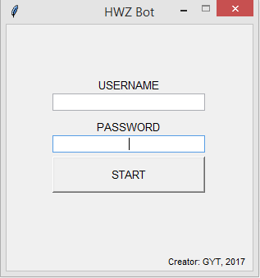

This is where you enter your password

This is where you enter your username

# 4. After logging in.

## 4.1. Status Page

Once you have successfully logged in, the app will prompt you. Then the GUI will change to the Status Page. On this page itself, it presents the user with several useful information of which will be explained in the image below.

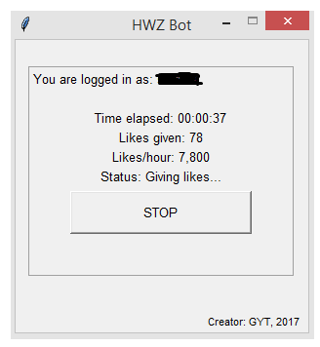

The status counter shows the user what the app is currently doing.

This counter automatically calculates the number of likes per hour

This counter keeps track of the number of likes given in the current session

This is a timer which shows how long the app has been running for.

The username of your account will show here

## 4.2. Statuses

In total, there are 4 main statuses and some other minor statuses. The 4 main statuses are regarding the main workload which is required to like posts. They are as following:

Setting up drivers: This status indicates that the app has just started and is starting the web drivers required for automating the task of giving likes. Besides starting the web drivers, the app also creates a new thread which obtains task for the web driver.

Scrapping thread page: This status indicates that the app is currently scrapping the html source of the page containing all the threads to obtain the thread links. These links will then be later used to further identify page links within each thread link.

Scrapping page links: This status indicates that the app is currently navigating to all the previously scrapped thread links to scrap for their page links. The identified page links will then be used by the web drivers to give likes later.

Giving likes: This status indicates that the app is currently clicking like buttons on each page link. This process takes the longest and will automatically update the likes given whenever actual likes are given.

# 5. Logging out

## 5.1. Stopping the app

Once you are done with giving likes, simply click the stop button shown below to stop the processes. However, do note that depending on where the “code” is, it will take a while to stop the threads especially in parts where the drivers are accessing the link.



Click the STOP button to stop the app.

## 5.2. Waiting for processes to stop.

As the processes are threaded, simply stopping them will not work and many tasks must be done before it can be stopped successfully otherwise there might be open connections etc. While the app is stopping, the status will update accordingly to show the user the progress. (Do note that the likes/hour shown below is unachievable in the actual app as the image below was taken from a test app).

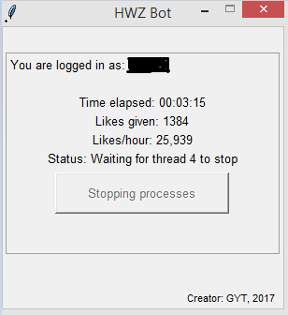

App is waiting for thread 4 to stop.

Once all the threads have exited, a prompt will appear as following.

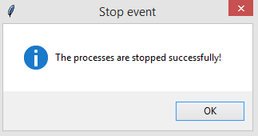

You can now proceed to click the red X button to close the app.

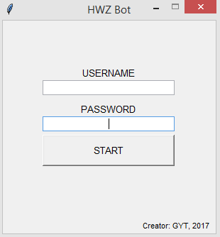

## 5.3. App fails to stop

Unfortunately, the stop process is not perfect and sometimes a rare bug will occur whereby the app fails to stop. After clicking the stop button, the status will be stuck at “Waiting for whichever thread to stop”. So, if this happens, the user will have no choice but to use task manager to close the open processes. The name of the processes to be killed from the task manager are:

* 4x PhantomJS.

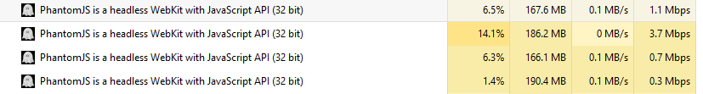

* Main app

